**DRESS CODE FOR GRADUATION**

**EITHER:**

* Dress whose length does not extend beneath the hem of the gown AND is not visible at the neckline.  If you choose to wear hosiery, select a tone that closely matches your skin color.

**OR**

* Dark or khaki dress slacks and a **WHITE** **dress shirt WITH a TIE** (casual golf/polo shirts are NOT permitted).

**SHOES** – All students must wear dress shoes. NO flip flops, Crocs, athletic shoes or **boots** of any kind are allowed. You will be walking a lot so please make sure that you are wearing comfortable shoes. If you don’t know if your shoes are permitted, see Mrs. Holmes (main office), Mrs. Garcia (319) or Mrs. Davis (IA-2).

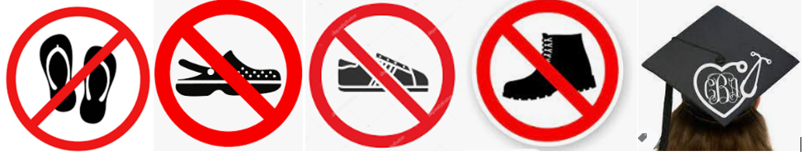



NO adornments (flowers, pins, medallions, jewelry) are to be worn on/with the caps and gowns with the *exception of* ***Leon High School issued***honor cords and Pierian honor stoles. Honor Cords and Stoles will be given out at graduation – not at Cap & Gown Pick-Up.